Multiple-choice section

|  |  |  |  |  |  |  |  |  |  |  |  |  |
| --- | --- | --- | --- | --- | --- | --- | --- | --- | --- | --- | --- | --- |
| Question | 1 | 2 | 3 | 4 | 5 | 6 | 7 | 8 | 9 | 10 | 11 | 12 |
| Answer | A | D | B | C | A | C | C | B | B | D | C | C |

Question 1 [6.1]

A

The oven tray is the shortest container as it is the lowest point on the graph.

Question 2 [6.1]

D

Section *H* moves further across the *x*-axis than the other 3 sections*.*

Question 3 [6.2]

B



Question 4 [6.2]

C

All points on the *x*-axis have a *y*-coordinate of zero. (3, 0)

Question 5 [6.2]

A

Each column of numbers in the table is an ordered pair (coordinate).

Question 6 [6.2]

C

(2, -3)

All points on the graph *y* = -3 have a *y*-coordinate of -3.

Question 7 [6.2]

C

For: Where *x* = 3, *y* = 2 × 3 + 3 = 9, so the point (3, 9) is on the line.

Question 8 [6.3]

B

*y* = 3*x* is true for all pairs of values.

Question 9 [6.2]

B

The line with equation  crosses the *y*-axis at (0, 3).

Question 10 [6.2]

D

*y* = 2 is a horizontal line, so the gradient is equal to 0.

Question 11 [6.2]

C

The line with equation  has a gradient of 100 which means that the line is very steep.

Question 12 [6.4]

C

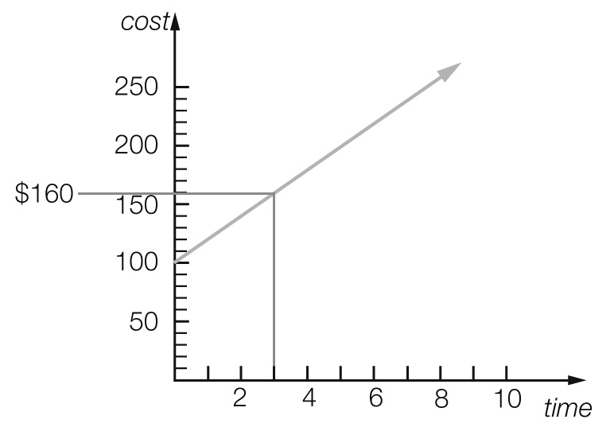

*C* = $160

Multiple-choice total marks: 12

Short answer section

Question 13 4 marks [6.2]

(a) The point (0, 0) is the *origin* of the *Cartesian* plane.

(b) The *gradient* of a line is a measure of its steepness.

(c) The *x*-intercept is where a line crosses the *x-axis* and the *y-intercept* is where a line crosses the *y*-axis.

(d) Lines with a *positive* gradient *slope* up to the right and lines with a *negative* gradient *slope* up to the *left*.

Question 14 3 marks [6.2]

(a) False

(b) True

(c) True

Question 15 3 marks [6.1]

(a) Height and weight (the axis labels)

(b) Xanthia (the point furthest along the *x*-axis to the right).

(c) Alex (the lowest point)

Question 16 2 marks [6.1]

(a) *D*. Flatter lines show lower speeds.

(b) *B*. Horizontal lines show no movement.

Question 17 3 marks [6.2]

*A* = (4, 3), *H* = (0, 4), *J* = (0, 0)

Question 18 2 marks [6.2]

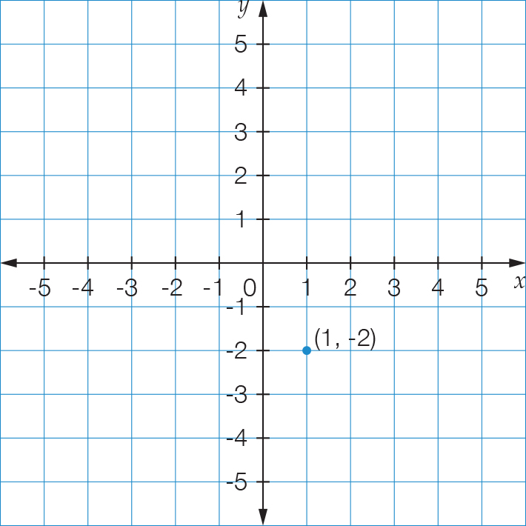

No, the two points are not in the same position, as the first number in an ordered pair represents the value of *x* and the second number represents value of *y*.

Question 19 6 marks [6.2]

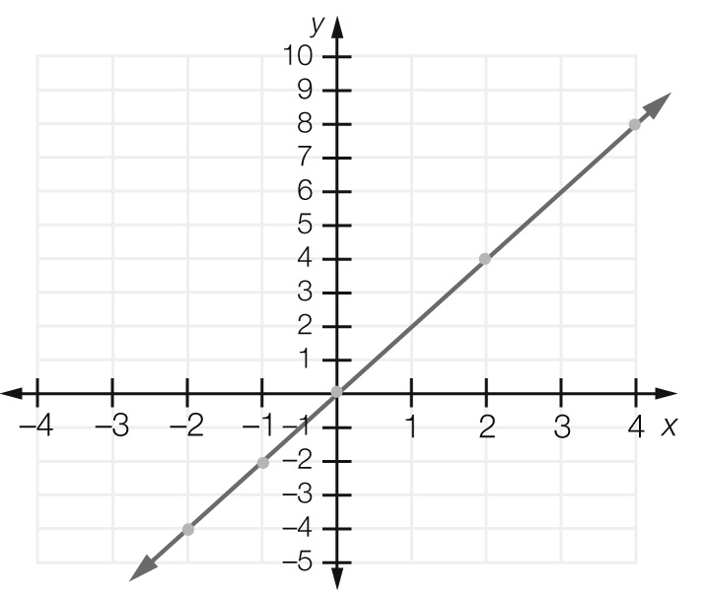

Question 20 4 marks [6.2]

For the line with equation: *y* = 2*x* + 6

(a) For *x* = 2, *y* = 2  2 + 6 = 10: (2, 10)

(b) For *x* = -1, *y* = 2  -1 + 6 = 4: (-1, 4)

(c) For *x* = -2, *y* = 2  -2 + 6 = 2: (-2, 2)

(d) For *x* = 3, *y* = 2  3 + 6 = 12: (3, 12)

Question 21 1 mark [6.3]

Gradient of zero passing through (1, 2). Rule: 

Question 22 1 mark [6.3]

Vertical line through (6, 2). Rule: 

Question 23 4 marks [6.3]

(a) 

(b) 

Short answer total marks: 33

Extended answer section

Question 24 6 marks [6.1]

(a)

|  |  |  |  |  |  |
| --- | --- | --- | --- | --- | --- |
| Distance from start (km) | 0 | 500 | 500 | 900 | 900 |
| Petrol in tank (L) | 40 | 10 | 40 | 20 | 40 |

(b)

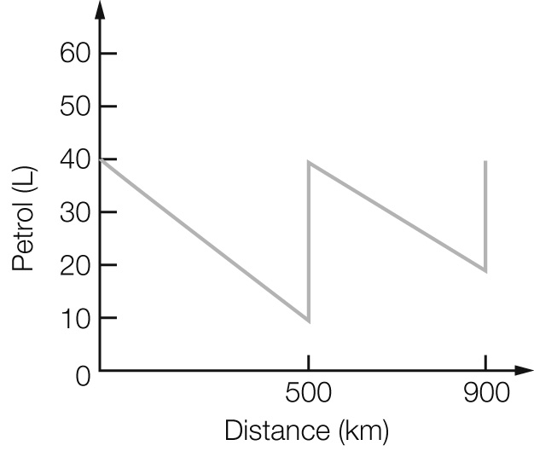

(c) The car used 30 L over 500 km (6 L/100 km) for the first part of the trip, and 20 L over 400 km   
(5 L/100 km) for the second part of the trip.

(d) The line falls more steeply for the first part.

Question 25 5 marks [6.3]

(a)

|  |  |
| --- | --- |
| Group number  (*g*) | Number of matches  (*m*) |
| 1 | 2 |
| 2 | 3 |
| 3 | 4 |
| 4 | 5 |
| 5 | 6 |

(b) *m* = *g* + 1

(c)

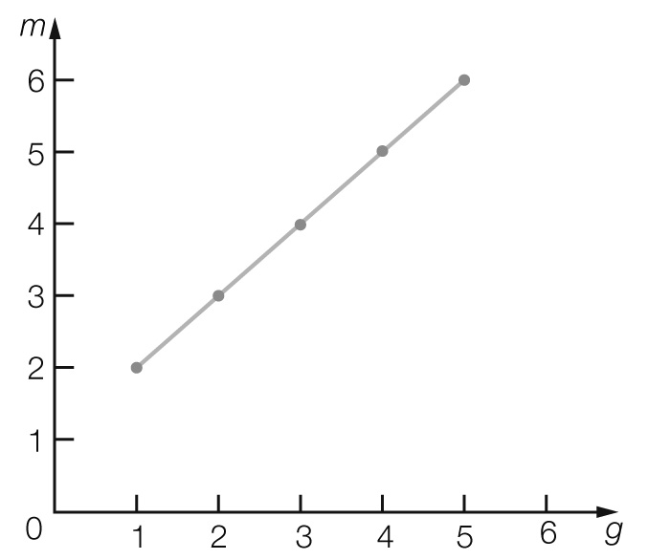

(d) For *g* = 10, *m* = 11

Question 26 6 marks [6.3]

(a)

|  |  |  |  |  |  |
| --- | --- | --- | --- | --- | --- |
| Hours worked, *t* | 0 | 1 | 2 | 3 | 4 |
| Cost, *C* | 40 | 70 | 100 | 130 | 160 |

(b)

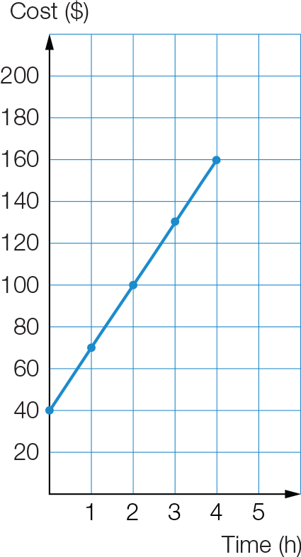

(c) $190

(d) *C* = 40 + 30*t*

Question 27 5 marks [6.4]

|  |  |  |
| --- | --- | --- |
| (a) $2.50 | (b) *T* = 2 + 0.5*p* | (c) *T* = 2 + 0.5 × 20 = $12 |

Extended answer total marks: 22

TOTAL test marks: 67